Week 4 Exercises: REST APIs and Platform Specific Development
Part 1: REST APIs
- A REST API is a way for applications to communicate over the internet using standard HTTP requests. A server exposes “endpoints” (URLs), and a client like my app sends requests to those URLs to get or send data, usually in JSON format. REST is a common style for building these web services.
- A GET request is an HTTP method used to retrieve data from a server without changing anything. When my app wants to read a list of items from an API, it sends a GET request to the endpoint URL, and the server responds with the data.
- JSON (JavaScript Object Notation) is a lightweight, text-based format for storing and exchanging data. It uses key-value pairs and arrays, is easy for both humans and machines to read, and is the most common format REST APIs use to send data back to an application.
- Fetch is a JavaScript function that sends a request to URL and returns the response. Async marks a function as asynchronous, meaning it can wait for slow operations without freezing the app. Await pauses inside an async function until a promise like a fetch finish, so the code can then use the result. Together they let the app request data and handle the response cleanly once it arrives.
- useEffect runs code at a specific point in a component’s life, such as right after the screen first renders. When fetching data, it lets the app start the request automatically as soon as the screen opens, and by giving it an empty dependency array the fetch runs only once instead of on every re-render.
- Because fetching data from the internet takes time and can fail. Without a loading state the user sees a blank screen and thinks the app is broken; without an error state the app may crash or show nothing if the request fails. Handling these states (a spinner while loading, a message on error, a message when empty) makes the app reliable and user-friendly.
- A network error means the request never reached the server or got no response at all. For example, no internet connection. An HTTP error like 404 means the request did reach the server and it responded, but with a problem status: 404 means the requested resource was not found. In short, a network error is a failure to connect, while an HTTP error is a valid response reporting that something went wrong.
Part 2: Retrieve Data from a REST API
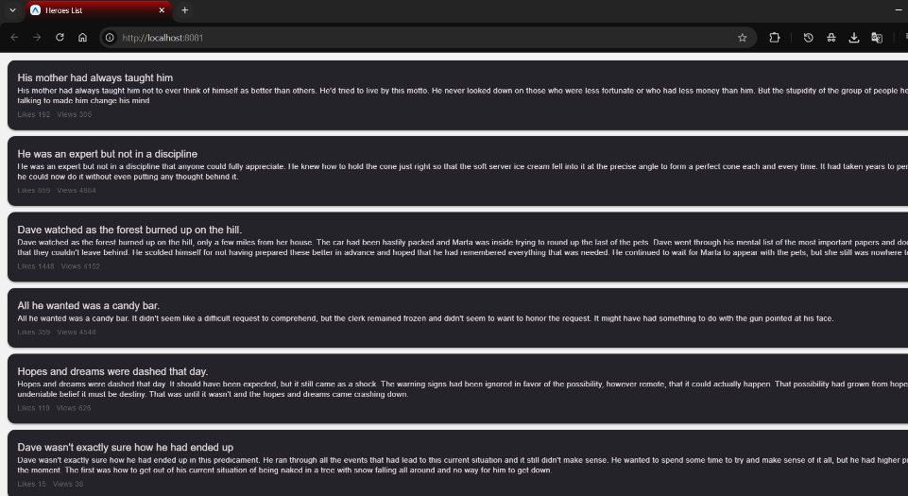
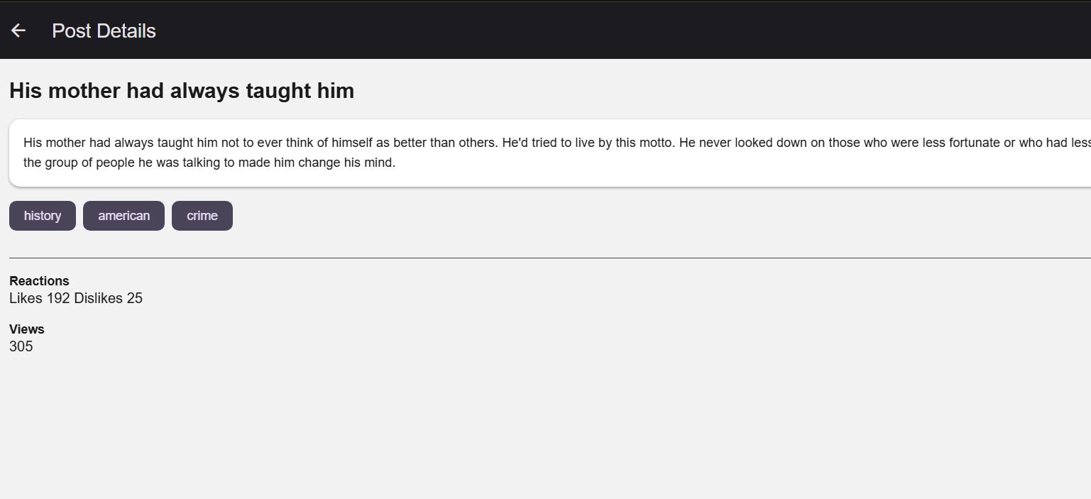

Part 3: Loading and Error States
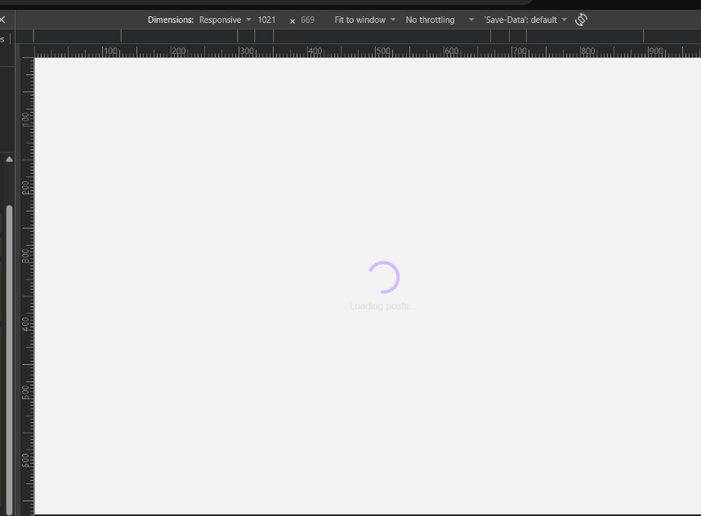
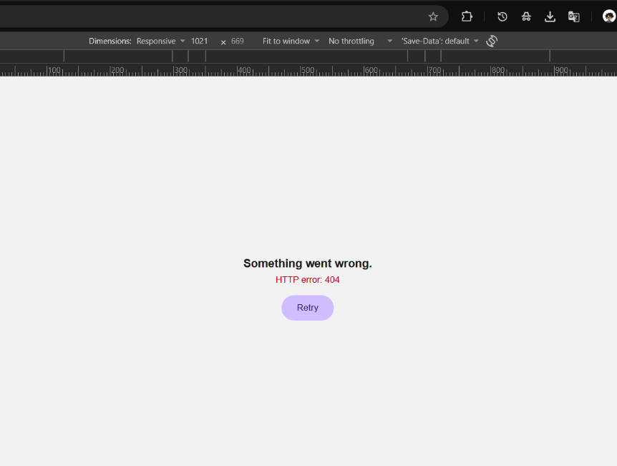

Part 4: Filter the Retrieved Data
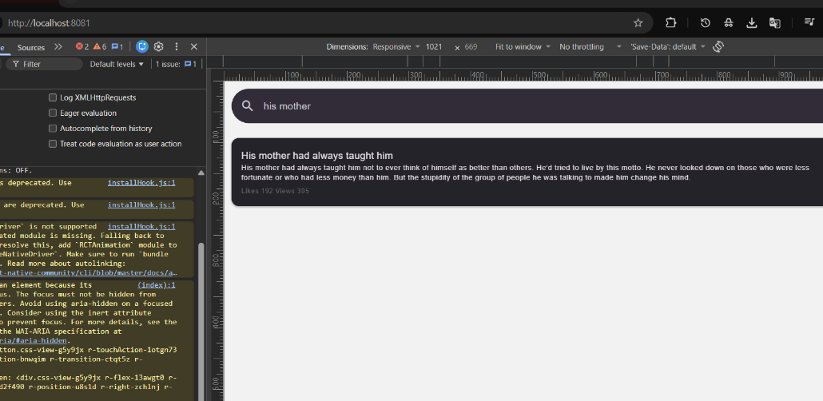
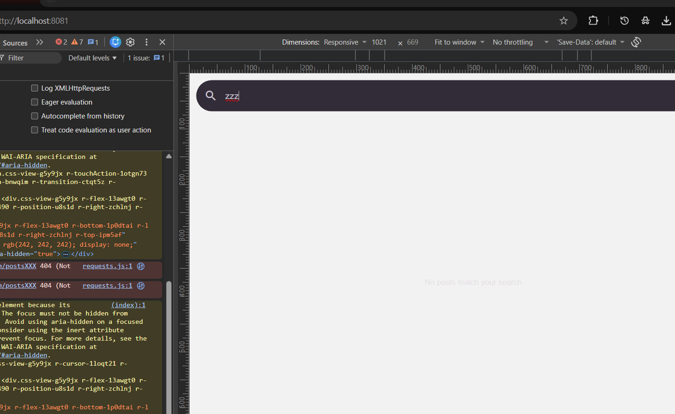

Part 5: Details Screen
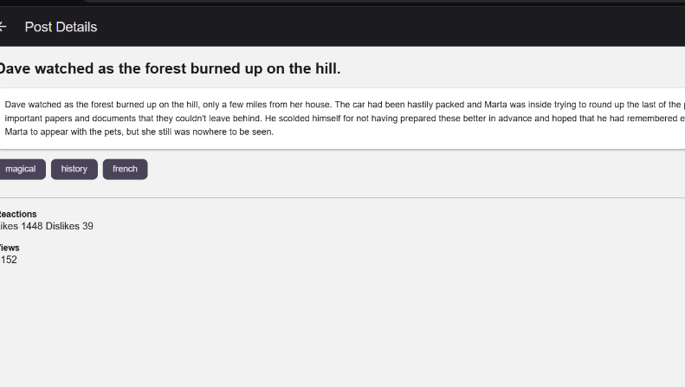
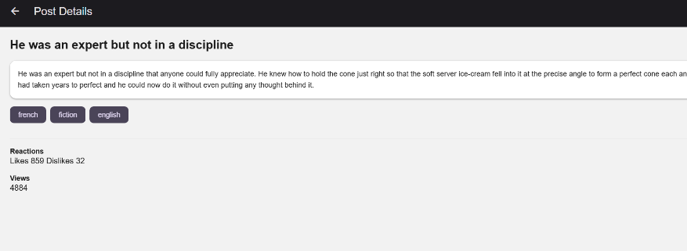

Part 6: Platform-Specific Development
6.1 Explore the Current Platform
- A string telling us which platform the app is running on such as “android”, “ios”, or “web”.
- It returns a different value depending on the platform. We give it an object with keys like android, ios and default, and it picks the value for the current platform. It is a clean way to set platform-specific values without writing if statements.
- Because the two systems have different design guidelines and conventions. Android follows Material Design and iOS follows Apple’s Human Interface Guidelines, so fonts, shadows, spacing, and some component behavior differ. Matching each platform’s conventions makes the app feel native.
- They let us write separate implementations of the same component for each platform. React Native automatically picks the right file based on the platform when we import the component without the extension, keeping platform-specific code cleanly separated.

6.2 Add a Small Platform-Specific UI Difference
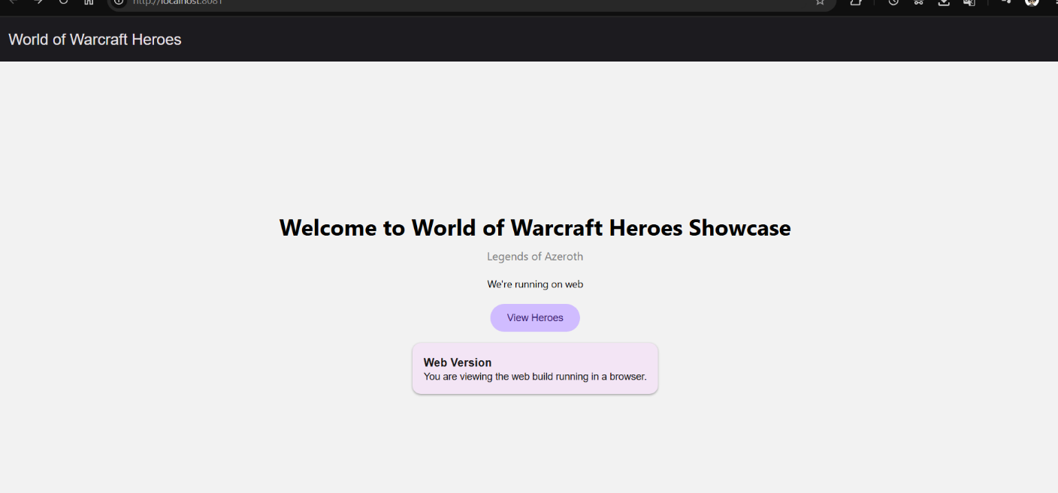

6.3 Create a Platform-Specific Component
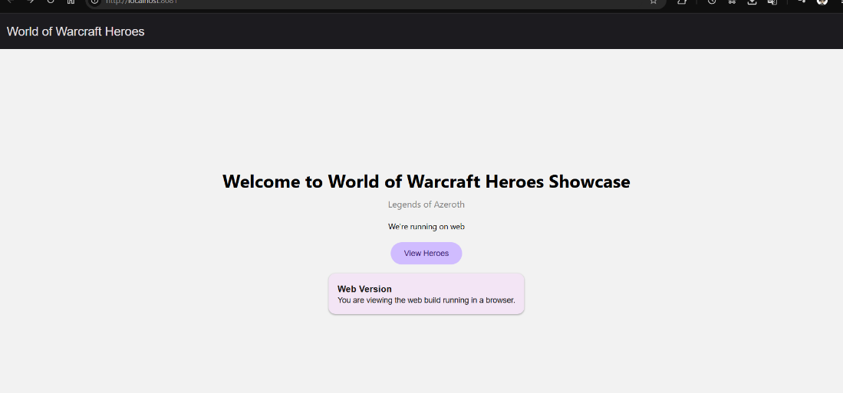

Part 7: Explore One More Platform Difference
- Shadows work differently on each platform. On iOS we use shadowColor, shadowOffset, shadowOpacity, and shadowRadius. On Android those are ignored and we use the elevation property instead, which controls the shadow depth and stacking order.
- If we only set the iOS shadow properties, the component will have a shadow on iOS but look flat on Android. To get a consistent look on both platforms, we have to set both the shadow properties and elevation.
- We can set both sets of properties in the same style, or use Platform.select() to apply the right one per platform. Component libraries like React Native Paper handle this internally, which is one reason using them is convenient.
Part 8: Reflection
- In Week 3 the data was a local file, so it loaded instantly and could not fail. With a REST API the data comes from the internet using fetch, which takes time and can fail, so I had to handle loading, error, and empty states and fetch the data with async/await inside useEffect.
- Because the request takes time to complete. Without a loading state the user would see a blank screen and might think the app is broken. A loading indicator tells them the data is on its way.
- I temporarily added the DummyJSON delay parameter (?delay=5000) to make the response slower, reloaded the screen, and confirmed the spinner showed for a few seconds before the posts appeared. Then I removed the delay.
- I temporarily changed the API URL to an incorrect one, reloaded, and confirmed the app did not crash, showed the error message, and displayed the Retry button. Then I restored the correct URL and pressed Retry to confirm the data loaded again.
- Fetching retrieves data from a remote service over the internet. Filtering processes data that is already in the app, narrowing down what is shown without making another request.
- The search text is stored in React state. I filter the already-fetched array with filter(), toLowerCase(), and includes() to keep only posts whose title or body contains the search text, and the FlatList shows that filtered list. It updates as the user types and shows a no-match message when nothing fits.
- I used Platform.select() to give the home screen different top padding depending on the platform, and I displayed the current platform with Platform.OS.
- When a component is imported without a file extension, React Native automatically picks the file matching the current platform: the.android.js file on Android, the.ios.js file on iOS, and the.web.js file on web.
- I used Claude to help structure the fetch logic and the loading and error states and to explain concepts like useEffect and Platform.select. One suggestion I tested myself was the artificial delay (?delay=5000) to check the loading state. I ran it, watched the spinner appear, and confirmed it worked before removing the delay, so I verified the behaviour rather than assuming it.

